Electrogels
Electrically collapsible hydrogels with enhanced mechanical toughness
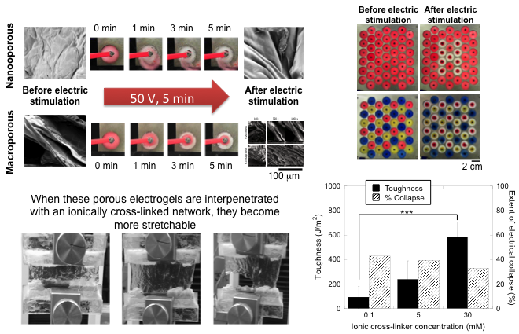

A Harvard MRSEC team led by Clarke, Mooney, Parker, Suo, and Vlassak has developed new hydrogels that are both electrically responsive and mechanically tough. Poly(acrylic acid) hydrogels can be made to be macroporous and therefore capable of rapid volumetric collapse (top left image sequences). These electrically responsive hydrogels can be integrated into systems capable of rapid configurational changes using simple and inexpensive electronics (top right photographs). However, these electrically responsive hydrogels are not very mechanically tough, limiting their broad applicability. When they are interpenetrated with an ionically cross-linked network such as calcium cross-linked alginate, they become more mechanically tough and stretchable (bottom left image sequence). This enhancement in toughness (6-fold increase from 0.1 to 30 mM calcium, bottom right graph) only moderately reduces the ability of the gel to be electrically collapsed. These mechanical enhancements may enable electrically responsive hydrogel materials to be used as actuators and artificial muscles.

