Sensor Skin
A platform for highly stretchable, biocompatible, transparent sensors

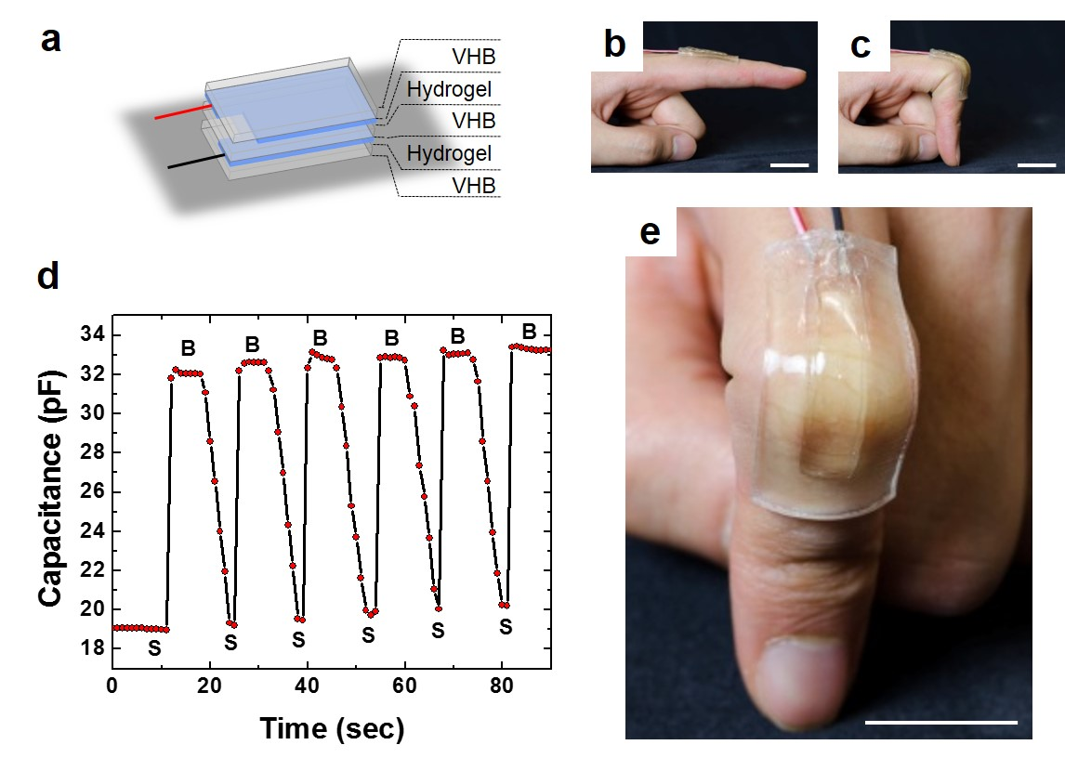

In work reported in Science (August 20, 2013) a Harvard MRSEC team led by Suo and Whitesides developed a transparent “ionic skin,” a sensor skin using ionic conductors. It senses signals with high stability and wide dynamic range, from a gentle touch of a finger to strains over 500%. The new ionic skin has attributes required for biocompatibility in medical devices and transparency for use in tunable optics. (a) As a demonstration, the electrodes were tin-plated copper, the ionic conductors were a salt-containing hydrogel, and the dielectric was an acylic elastomer (VHB). VHB was also used to cover the faces of the ionic skin. (b) The ionic skin was attached to a straight finger. (c) When the finger bent, the ionic skin stretched. (d) As the finger bent cyclically, the capacitance changed accordingly. ‘B’ denotes bent finger, and ‘S’ denotes straight finger. (e) The ionic skin was transparent. The scale bars in b, c, e are 2 cm.

