Hydroglyphics – Visualizing Patterns
from Wetting Contrast
Writing Secret Messages with Water

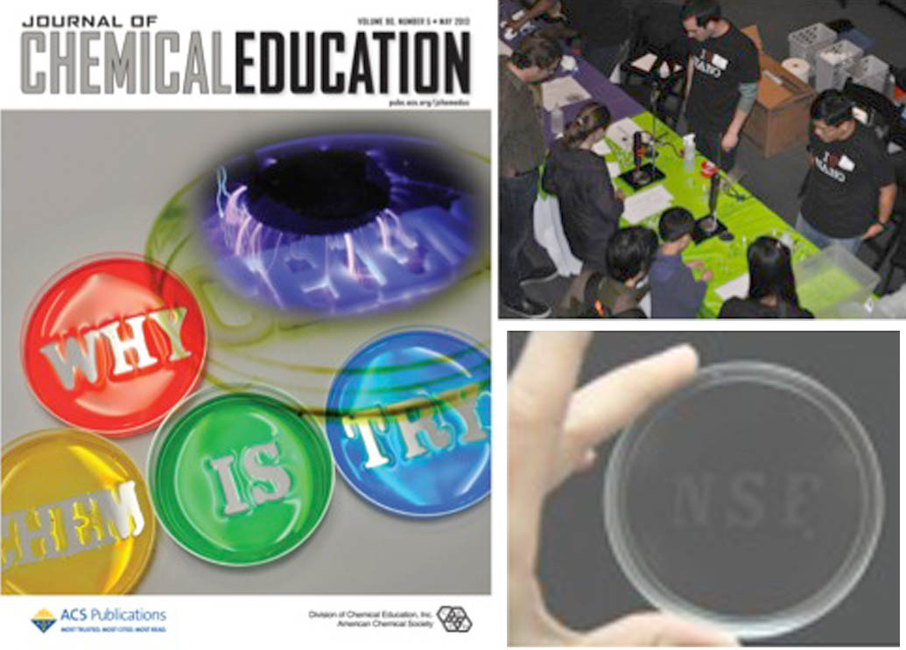

Joanna Aizenberg and her colleagues at the Harvard MRSEC developed Hydroglyphics to use readily accessible and safe materials to visually demonstrate the differences between hydrophobic and hydrophilic surfaces to a broad audience. This hands-on learning activity has been effective at teaching both elementary school students and their parents. The activity entails placing a shadow mask (usually the participant’s initials) on an optically clear hydrophobic polystyrene dish, corona treating the surface with a modified Tesla coil, carefully removing the shadow mask, and visualizing the otherwise invisible message or pattern by applying water, thus entitled Hydroglyphics. This engaging demonstration has been successful with large audiences at the Nanodays, the 2nd USA Science and Engineering Conference, and the annual Cambridge 8th Grade Science and Engineering Showcase. An article detailing the activity was featured on the May 2013 cover of Journal of Chemical Education.

