Education and Outreach Nugget
Multi-faceted Education and Partnerships at GEMSEC:
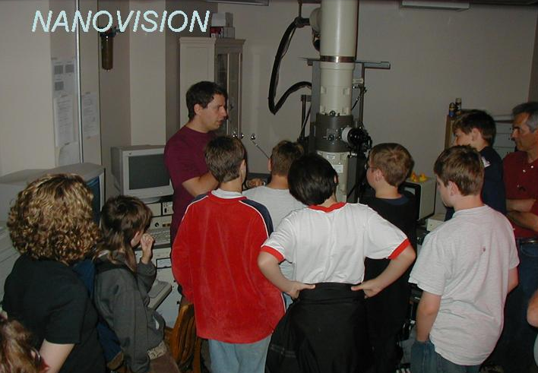
With a particular focus on engaging and including Native Americans in its entire range of programs, GEMSEC is weaving a fabric of education offerings to seamlessly support and complement its research thrusts. The programs address the needs of multiple audiences; (i) Furthering training of graduate and undergraduate students with interests in biomimetic science through: Annual, multi-day biomimetics workshops, Graduate level courses and teaching modules, Partnerships with industry, national labs, and other colleges and universities, Undergraduate curriculum on molecular biomimetics, Research Experience for Undergraduates program ; (ii) Engaging younger students and their teachers in learning about molecular Biomimetics via: High school level academic year and summer enrichment programs and internships, Research Experiences for Teachers, Visitations programs for younger students; and (iii) Familiarizing the broader public with this dynamic field by:Engaging and accessible public lectures delivered by dynamic speakers and Collaboration with the Pacific Science Center to create exhibits and programs

